Advantzware Open Analytics (AOA)

Parameter Screen User Manual

Full functionality to render AOA Reports and Dashboards to a locally installed Web Browser, requires the installation/configuration of a Progress Application Server, installation/configuration of Internet Information Services (IIS) and AOA Report/Dashboard Writer on the Advantzware Server. Additionally, our AOA Batch Scheduler is available for submitting AOA Reports to run off hours and/or on a predetermined schedule daily, weekly and or monthly as desired.

All AOA Reports will render into Excel regardless if any of the above components are installed.

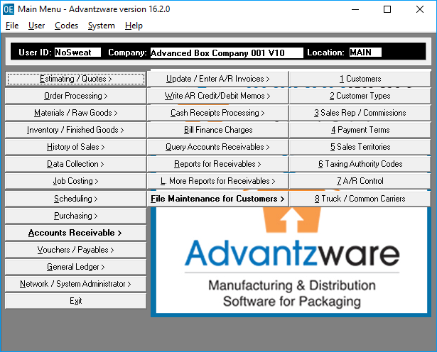

From anywhere within the Advantzware System, type CTRL-ALT-R to invoke the AOA Report Launcher.

Note: CTRL-ATL-D will invoke the AOA Dashboard Launcher.

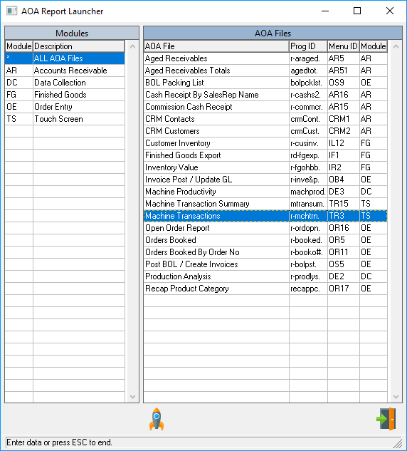

By default, the Launcher will display all the AOA Reports available alphabetically, but can be filtered by Module. Simply select the desired Module in the left-hand columns to display only those reports associated with the selected Module.

Click the Launch Icon  after selecting an AOA Report or double click the highlighted selection to run the parameter screen.

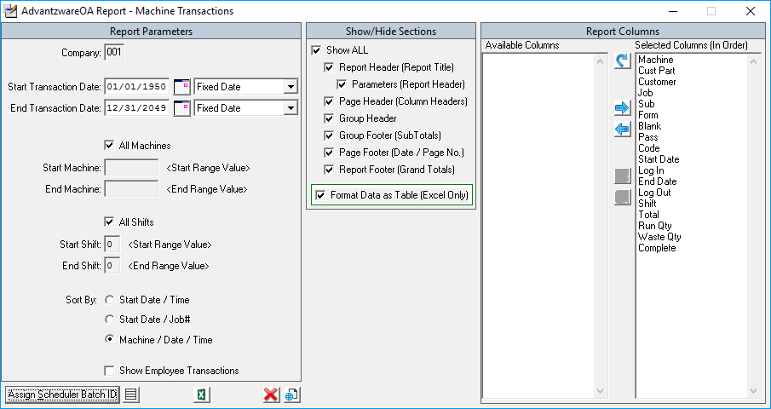

Left portion of the screen is unique Parameters for each AOA Report. When a Date Parameter exists, several predetermined values can be selected from the pull down as shown below.

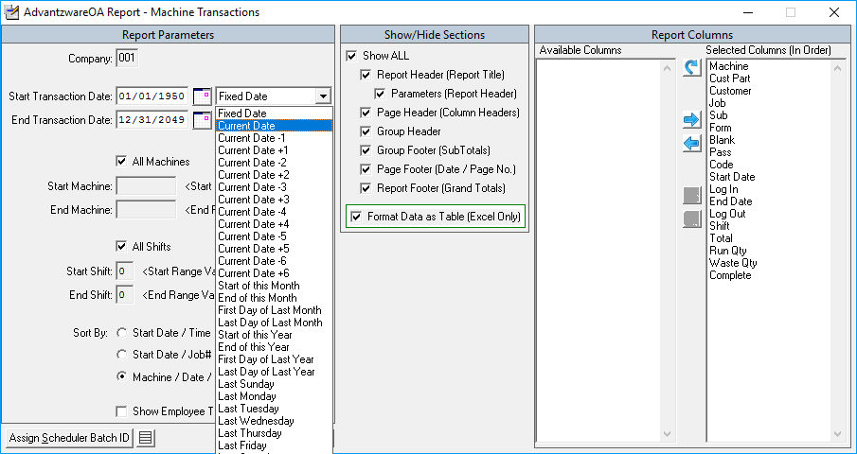

The value of these selections will be determined at run-time; this proves especially useful when an AOA Report is used in the AOA Batch Scheduler Module. Clicking the Calendar Icon  will invoke a popup Calendar to assist in specific date selections.



The Middle section, Show/Hide Sections allows the options of showing and/or hiding various parts of an AOA Report. Clicking the Show ALL parameter will toggle all this section’s parameter values On/Off as applicable. The last parameter in this section Format Data as Table (Excel Only) determines if the data of the AOA Report is to be formatted in a Table Grid with header filters when exporting to Excel.

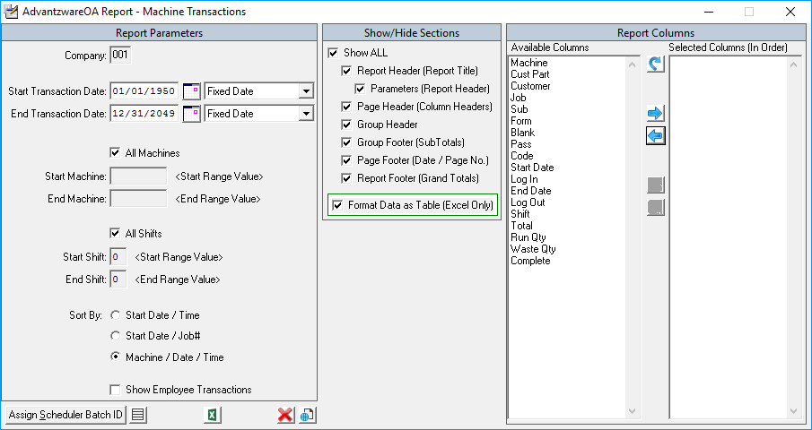

The right-side columns allow for the selection and ordering of the columns which appear in the AOA Report.



Click the Reset Selected Columns to Default Icon  will select all Available Columns and place them in the Default order in the Selected Columns.

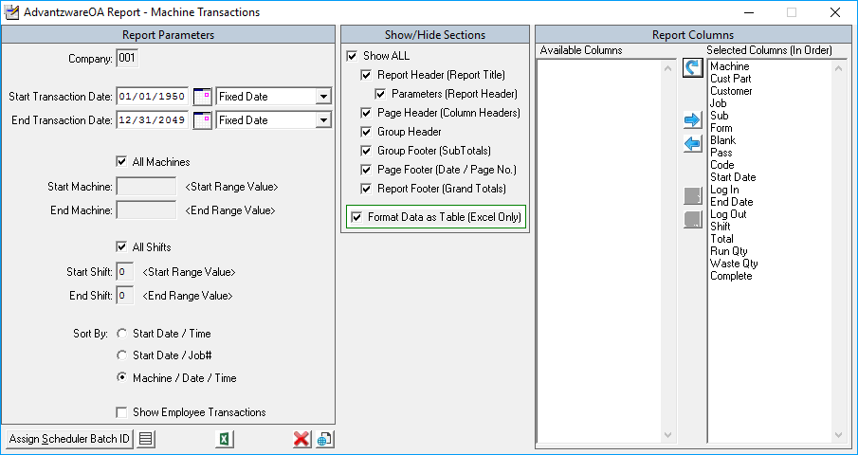

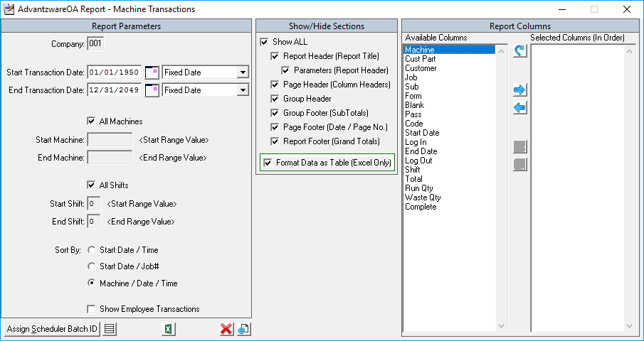

To Select any Available Column field for inclusion, highlight the Column and double mouse click or click the Add Available Column(s) to Selected Columns Icon .

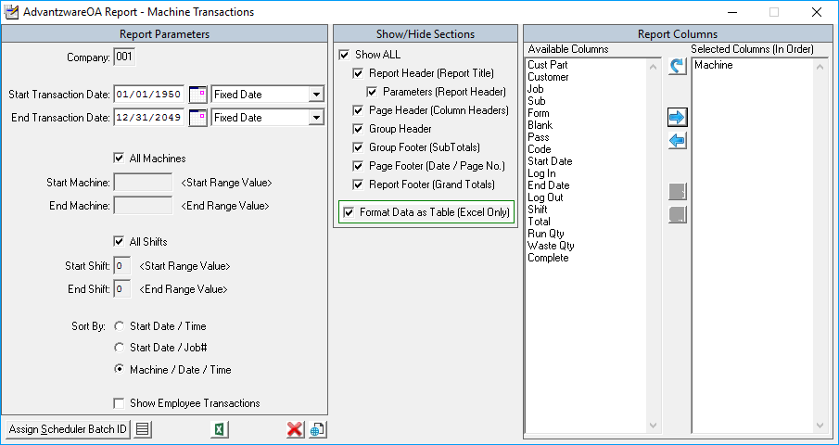

This can be done for multiple columns but selecting a column, then holding the CTRL key down while selecting additional columns.

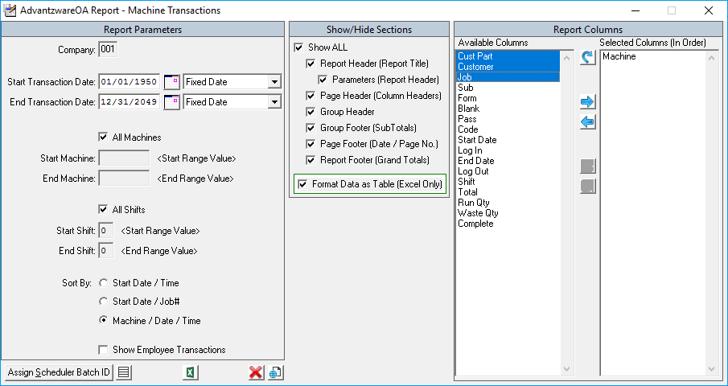

After all selections are highlighted, click the  to move the selections to the Selected Columns.

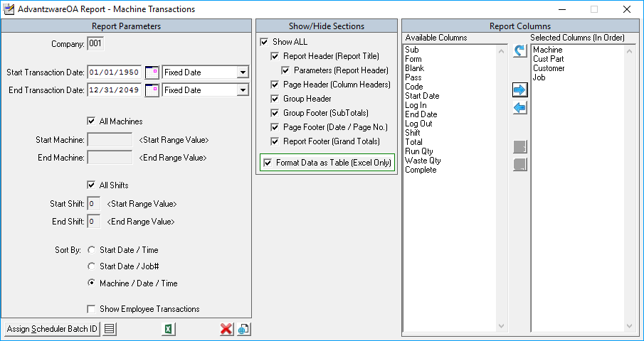

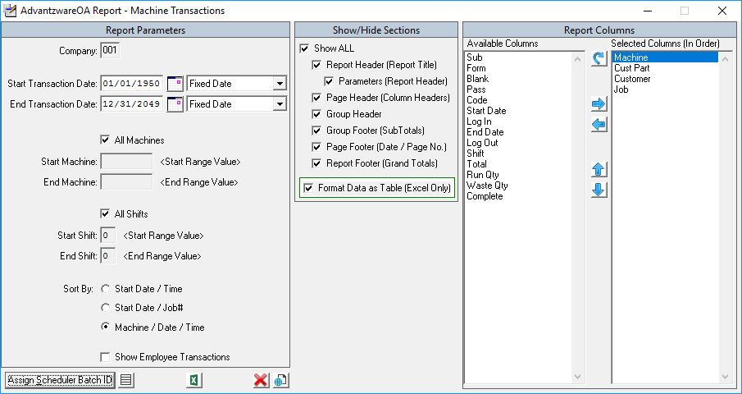

To remove Selected Columns, highlight the Column and double mouse click or click the Remove Selected Column(s) Icon .

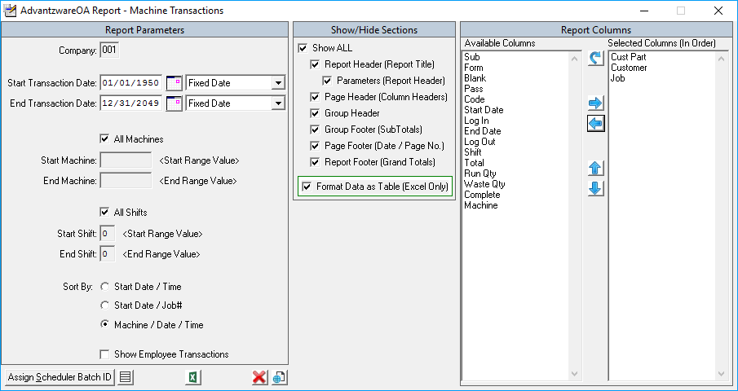

This can be done for multiple columns by selecting a column, then holding the CTRL key down while selecting additional columns.

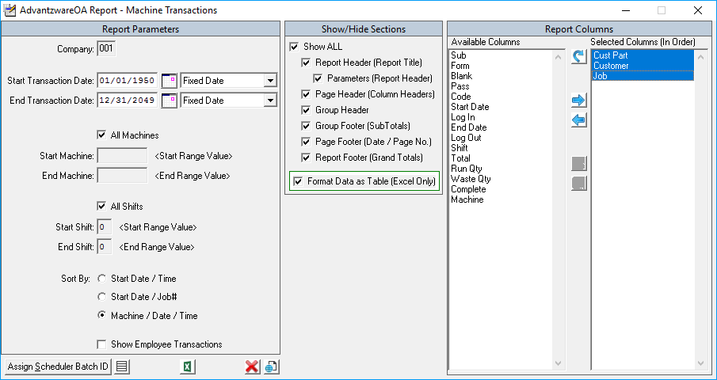

After all selections are highlighted, click the  icon to remove the selections from the Selected Columns.

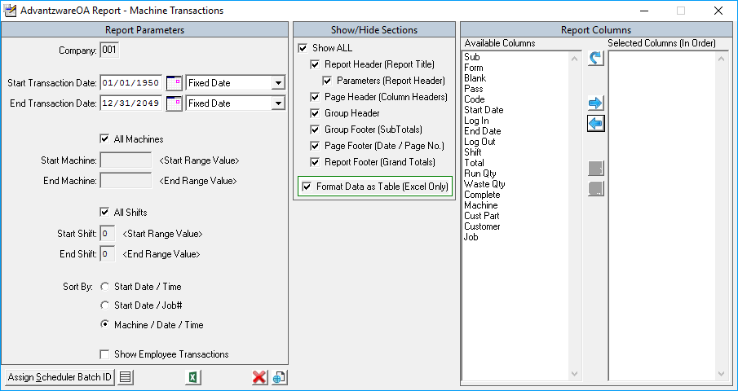



Once all the desired columns are placed into the Select Columns, the order in which the columns will present in left to right order within the AOA Report can be customized by moving columns up and/or down.

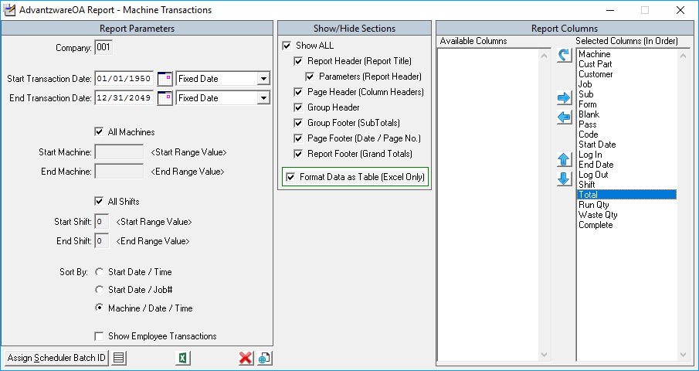

When only one column is selected, the Move Selected Column Up  and the Move Selected Column Down  Icons will enable.

Simply select either Icon to position the selected column higher or lower in the order. The order in which the columns appear will render them in the AOA Report from Left to Right.

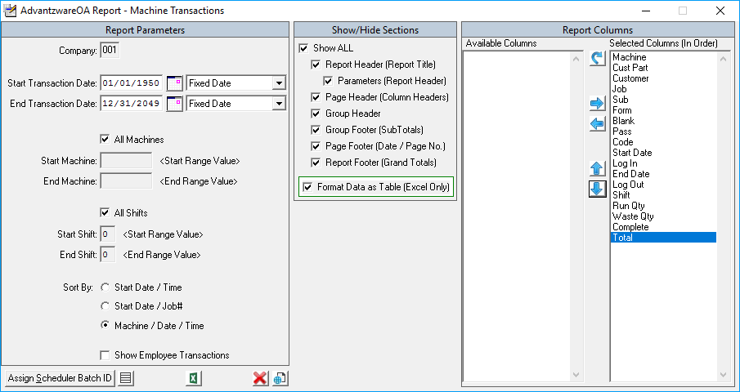

Once all the parameter values are set, the Show/Hide Sections are selected and the Columns have been selected and ordered, the AOA Report is ready to be rendered to a locally installed Web Browser or exported into Excel.

When AOA, Application Server and IIS are installed and configured, click the View Icon  to render the AOA Report to a Web Browser.

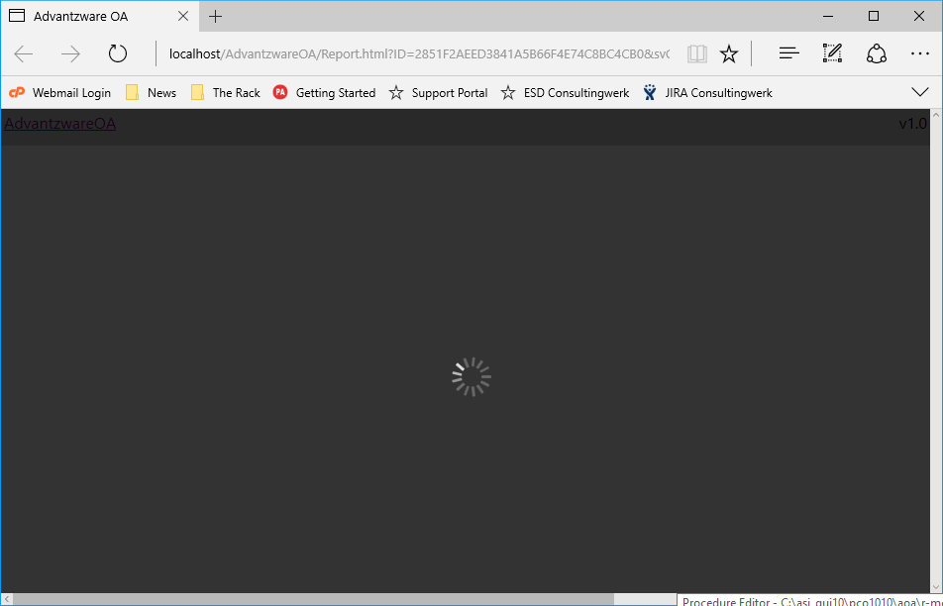

The above screen will appear while the AOA Report makes a connection with the Application Server.

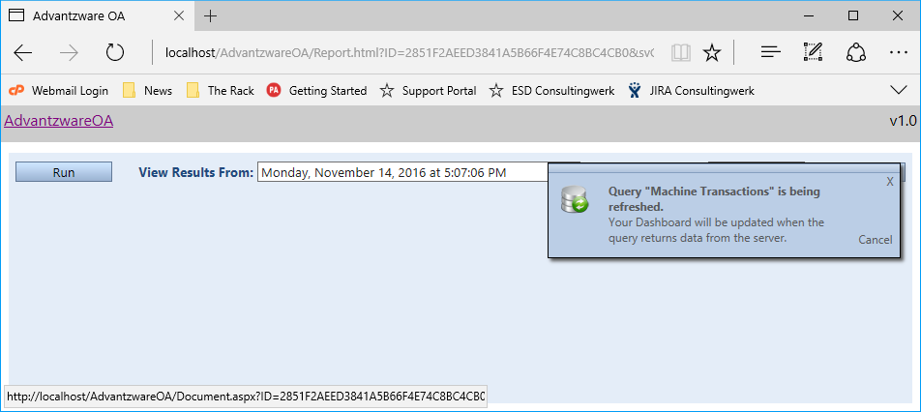

Once a connection occurs, the AOA Report executes the report query. The dialog box that appears in the upper right hand corner allows the query to be cancelled before it completes.

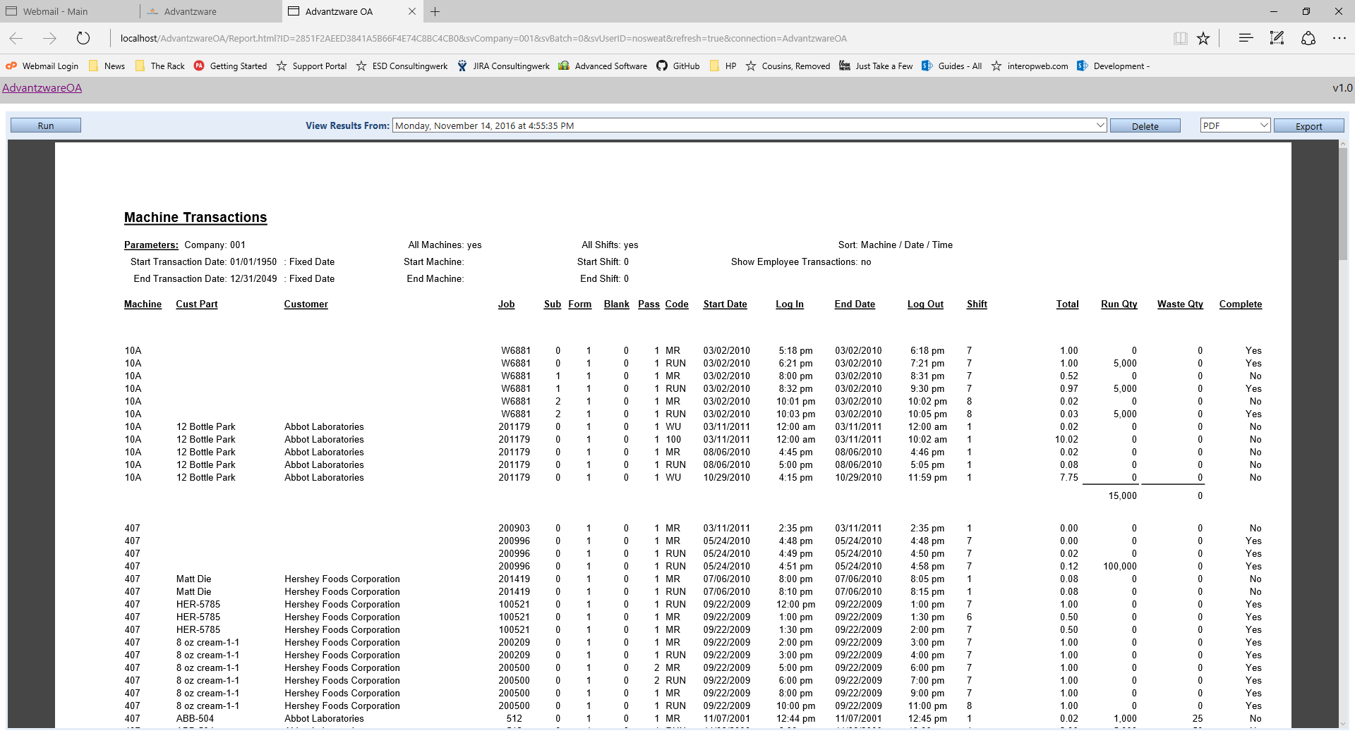

When the report query is complete, the AOA Report renders.

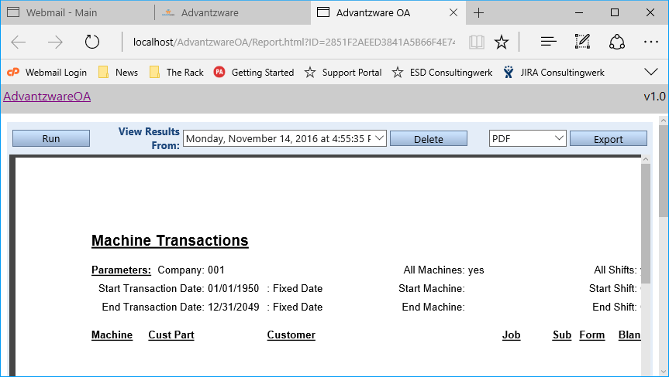

To Re-Run the AOA Report, click the “Run” button.

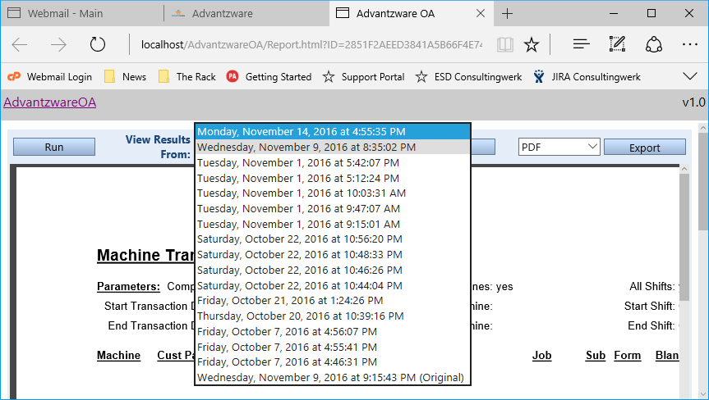

The AOA system retains the previous runs and can be viewed by selecting it from the “View Results From” pull down.

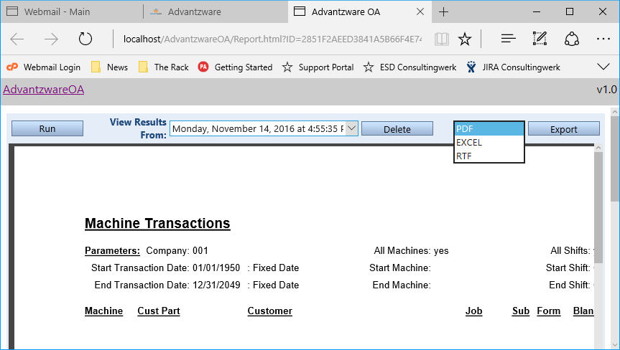

After an AOA Report is rendered, it can be Exported by selecting the type of export desired, “PDF, EXCEL or RTF” and then clicking the “Export” button.

To print an AOA Report, use the Web Browser’s print functionality.

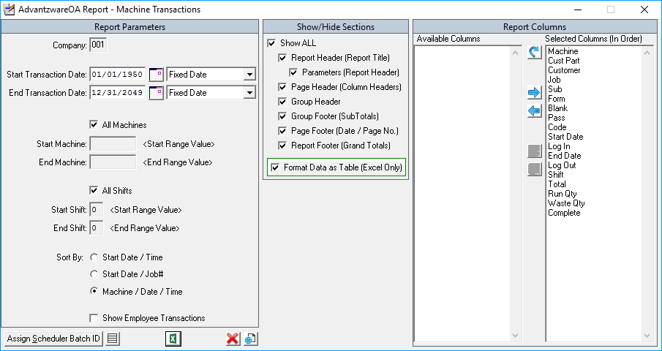

Even if none of the Applications necessary to render an AOA Report to a Web Browser are installed, an AOA Report can be exported to Excel by clicking the Excel Icon .

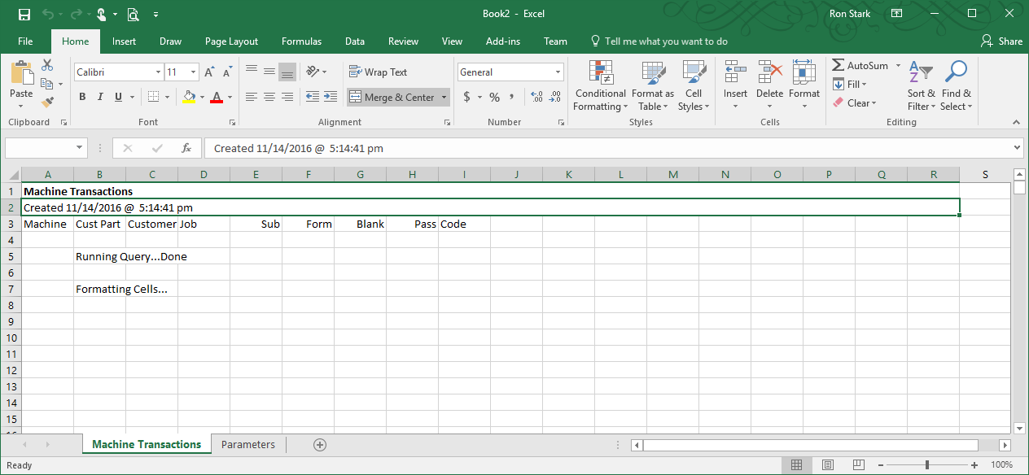

Once the report query is complete, the AOA Report renders in Excel.

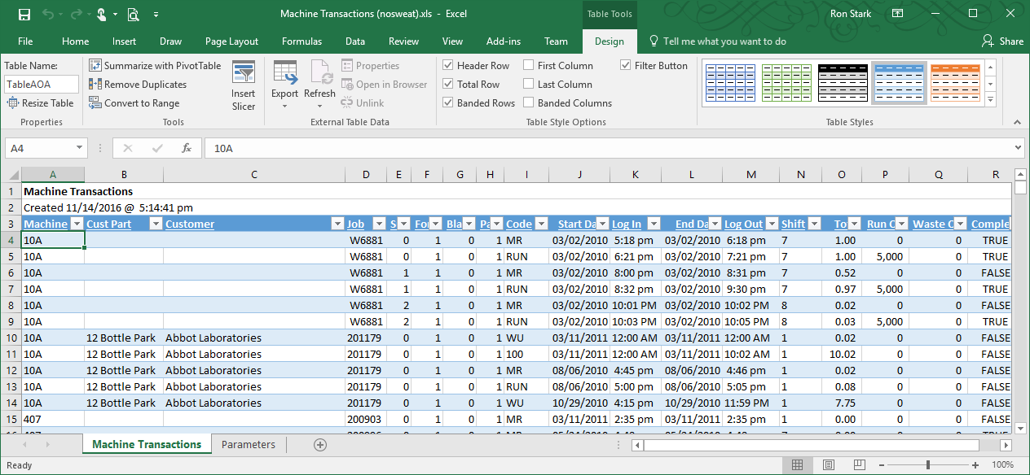

If Show Parameters is turned on, the Parameter values used by the report query can be viewed on the second sheet labeled “Parameters” tab.

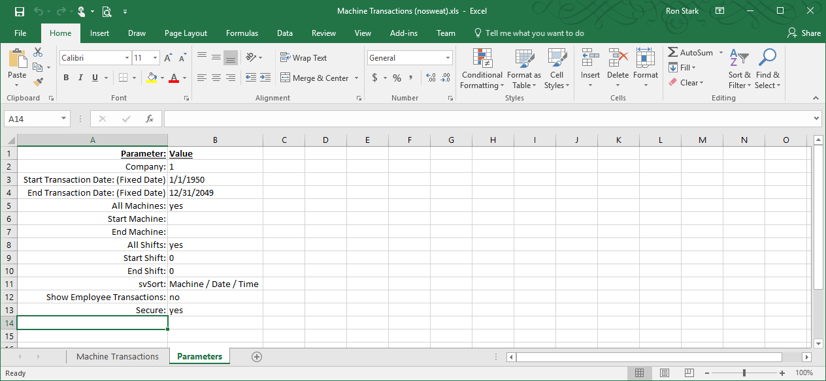



AOA Reports can be submitted to the AOA Batch Scheduler but first a Batch ID must be generated to record the Parameter values for the report. Click “Assign Scheduler Batch ID” button and a prompt will display showing the Batch ID value. This Batch ID value will be used in the AOA Batch Scheduler along with the Company and User ID values, to indicate what Parameter values will be used.

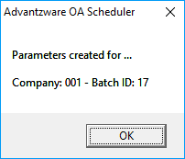

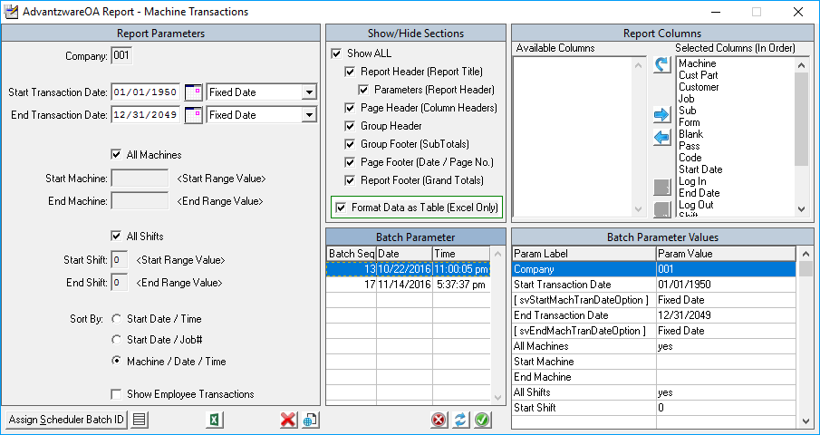

Accessing Scheduler Batch ID’s associated with this report is done by clicking the “Show Batch Parameter Values” Icon . Clicking this icon again will close the Batch Parameter and Batch Parameter Values display. The middle bottom columns show Batch ID’s along with the Date and Time the Batch ID was generated. The bottom left columns show the Parameter Label, as shown on the left side of the Parameter Screen, along with the values entered.

* Delete Batch ID – removes the selected Batch ID



*  Apply Batch Values to Parameter Values – will populate the left side Parameters with the selected Batch ID values
*  Save Parameter Value to Batch ID – will update the selected Batch ID with the left side Parameter values

Click the Close Icon  to close the AOA Parameter Screen.